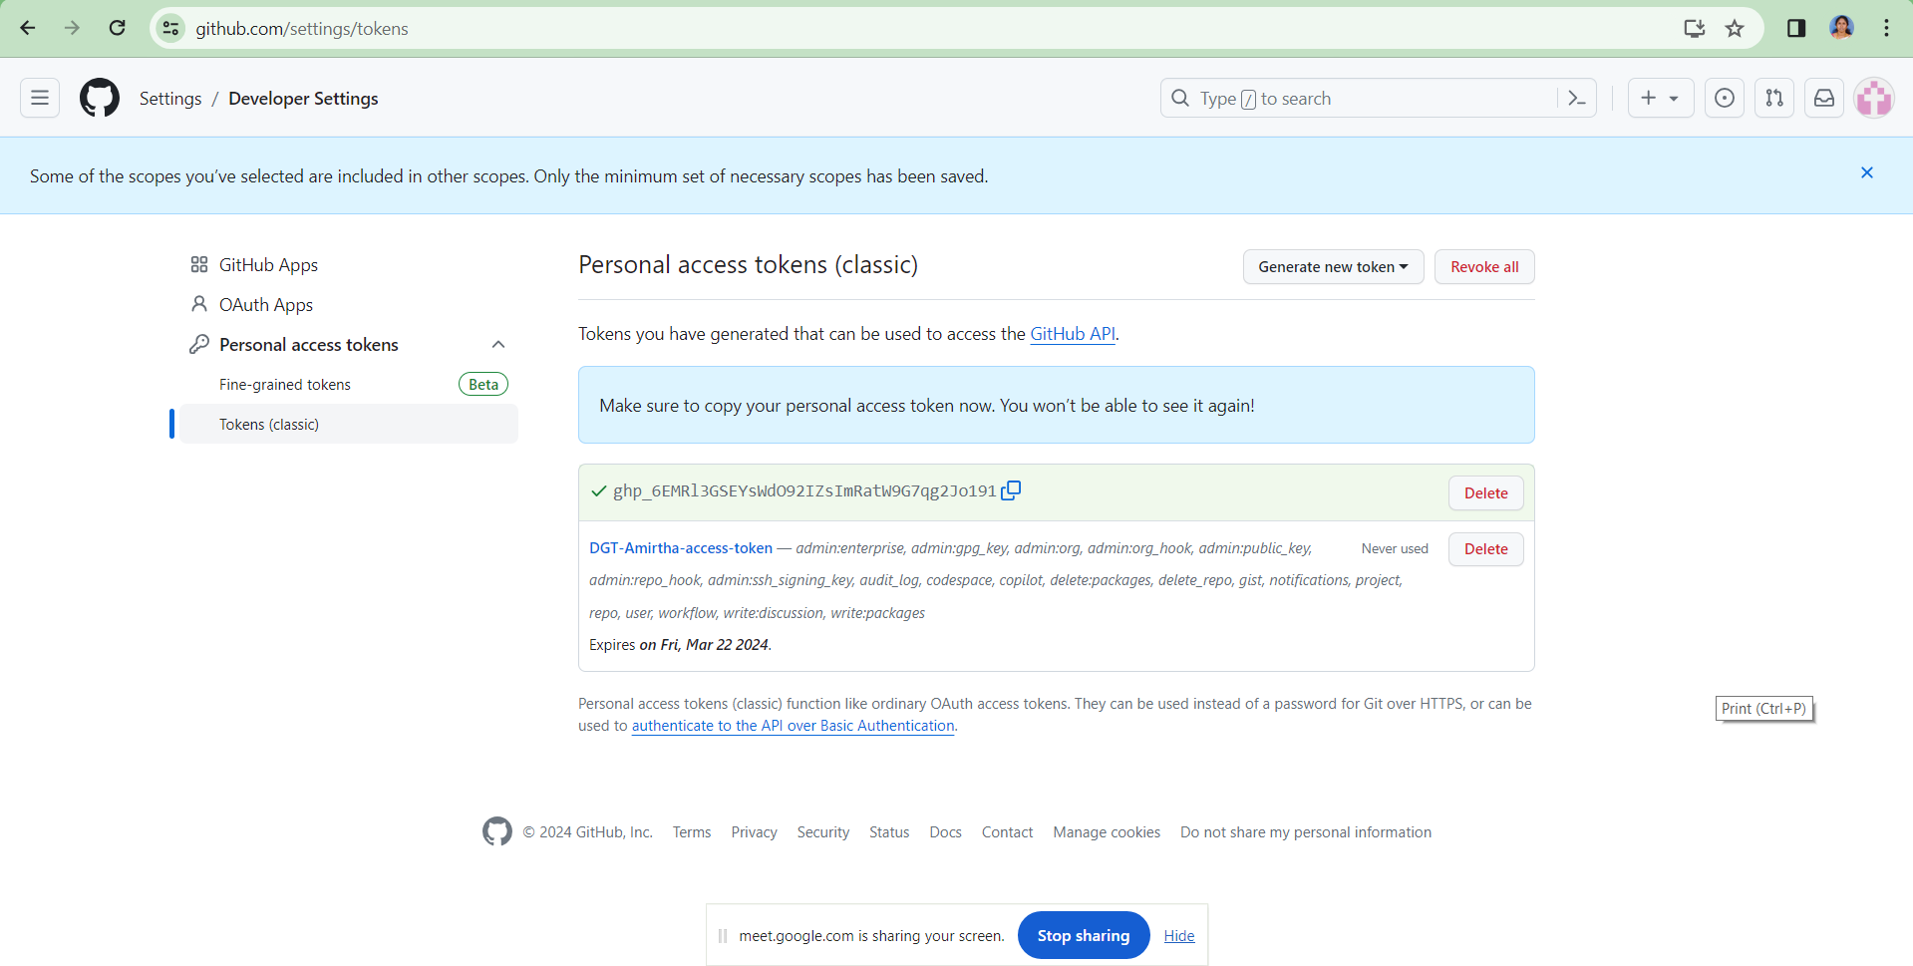

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

https://DGTAmirtha: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
@github.com/HybridheroV2/hh-refactoring-book.git

Git config --global --list
git config --global user.email "amirtha.lakshmi@dreamstechnologies.com"
git config --global user.name "DGTAmirtha"

